Jira : Filters and JQL (Advanced Search)

Overview
Jira Filters and JQL (Jira Query Language) are powerful features used to search, organize, and analyze issues efficiently across projects. While basic search allows users to filter issues using simple UI options, JQL enables advanced, precise, and reusable queries that are essential for large projects, reporting, dashboards, and automation.

Jira Filters
A Filter in Jira is a saved search result created using either Basic Search or JQL. Filters help users quickly access frequently needed sets of issues without recreating searches every time.
Key Characteristics of Filters:
- Filters are based on JQL queries
- Can be private or shared with users, groups, or projects
- Used in:
  - Dashboards
  - Agile boards
  - Reports
  - Automation rules
- Permissions control who can view, edit, or subscribe to a filter
Common Use Cases:
- All open bugs in a project
- Issues assigned to a specific user
- High-priority defects pending testing
- Issues in the current sprint

JQL (Jira Query Language)
JQL is Jira’s structured query language used to perform advanced searches on issues. It allows users to filter issues based on multiple conditions using fields, operators, functions, and keywords.
Why JQL is Important:
- More powerful than basic search
- Enables complex conditions (AND / OR / NOT)
- Required for:
  - Advanced filters
  - Custom dashboards
  - Automation triggers
  - Board configurations

Basic Structure of JQL
FIELD OPERATOR VALUE
Example:
project = "Website Development"
Multiple conditions:
project = "Website Development" AND status = "In Progress"

Commonly Used JQL Fields
- project – Project name or key
- issuetype – Bug, Story, Task, Epic
- status – Open, In Progress, Done
- priority – High, Medium, Low
- assignee – User responsible for the issue
- reporter – User who created the issue
- created, updated, resolved – Date fields
- labels, components, fixVersion

Operators in JQL
- = equals
- != not equals
- IN, NOT IN
- >, <, >=, <= (dates, numbers)
- ~ contains (text search)
Example:
issuetype IN (Bug, Task)

JQL Functions
Functions allow dynamic searching.
Common functions:
- currentUser()
- membersOf()
- openSprints()
- startOfDay(), endOfDay()
Example:
assignee = currentUser()

Sorting Results
Use ORDER BY to sort search results.
Example:
project = DEV ORDER BY priority DESC, created ASC

Advanced Use Cases
- Bugs unresolved for more than 7 days
- Issues created in the last sprint
- Stories without story points
- QA-pending defects in current sprint

Filters in Dashboards and Boards
- Filters act as data sources for:
  - Gadgets (Pie Chart, Filter Results, Sprint Health)
  - Scrum/Kanban boards
- One well-written filter can be reused in multiple places

Best Practices
- Use meaningful filter names
- Share filters with correct permissions
- Avoid overly complex queries unless necessary
- Regularly clean unused filters
- Prefer JQL over basic search for accuracy

Hands-on Practice:
Applying Basic Filter to search work item:

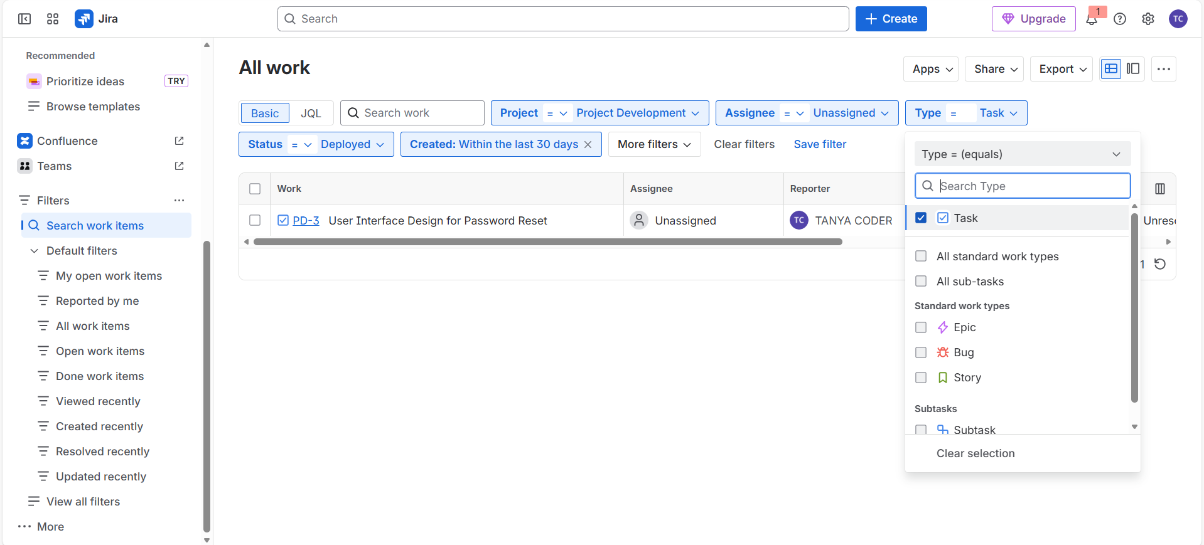

Getting JQL for the applied filter:

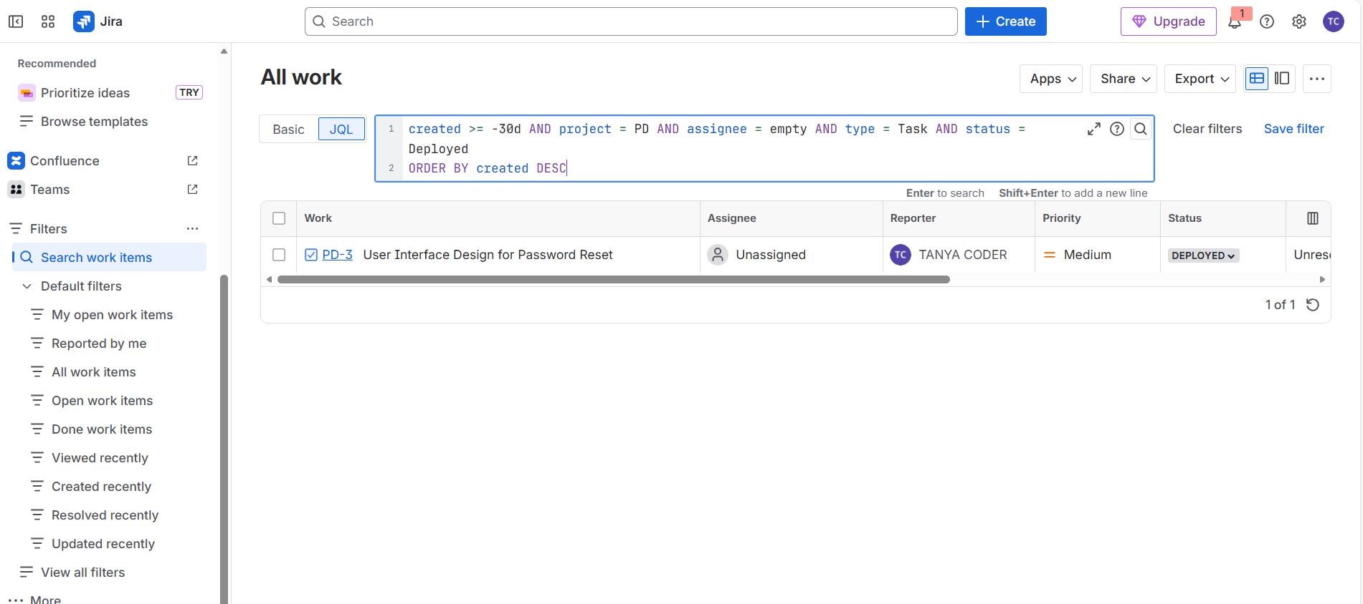

Creating custom filter using JQL:

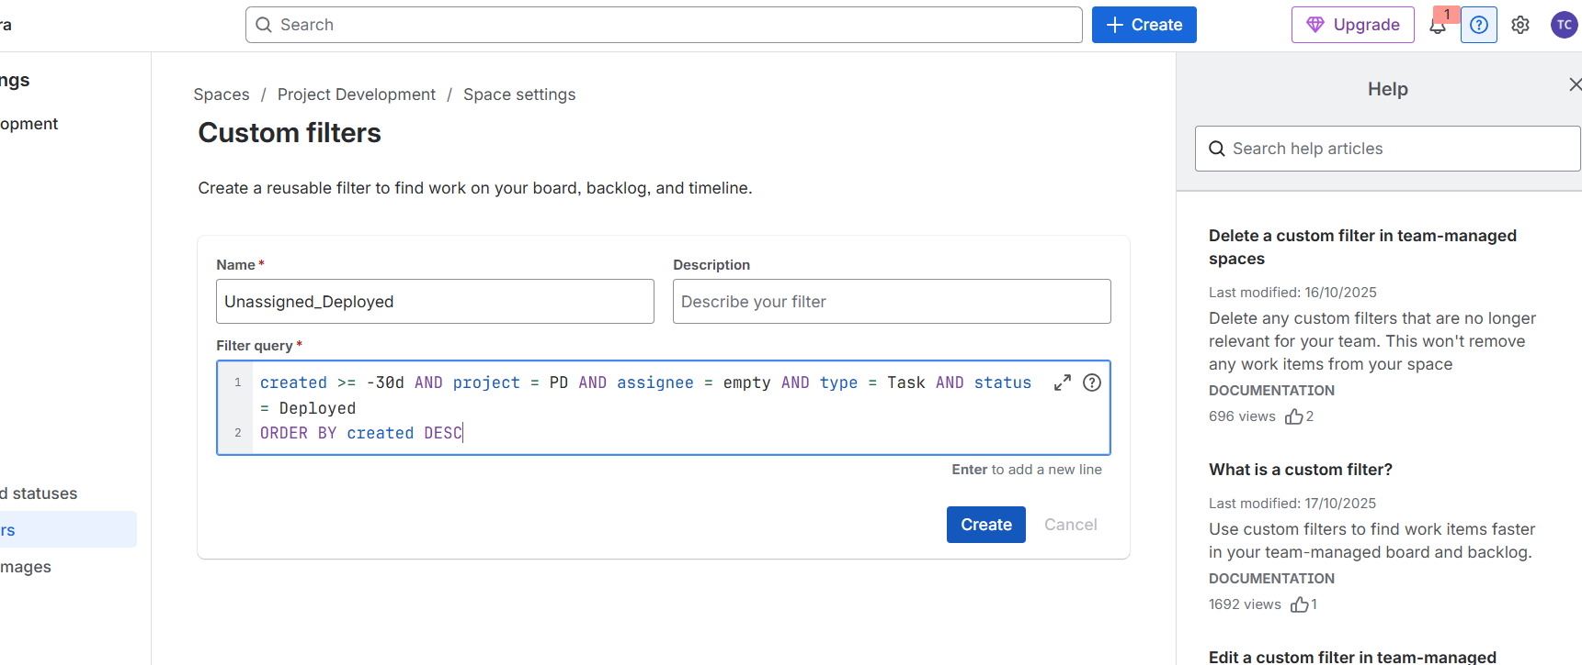

Applying the custom filter created on the board:

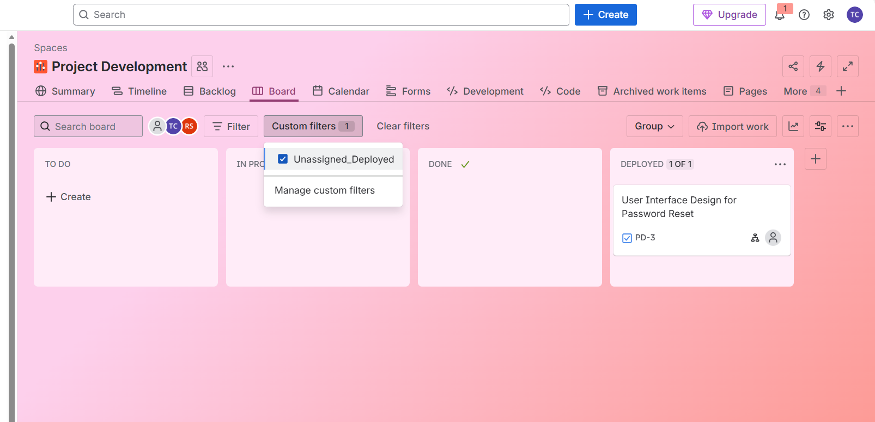

Writing JQL and searching for the specific work items based on specific conditions:

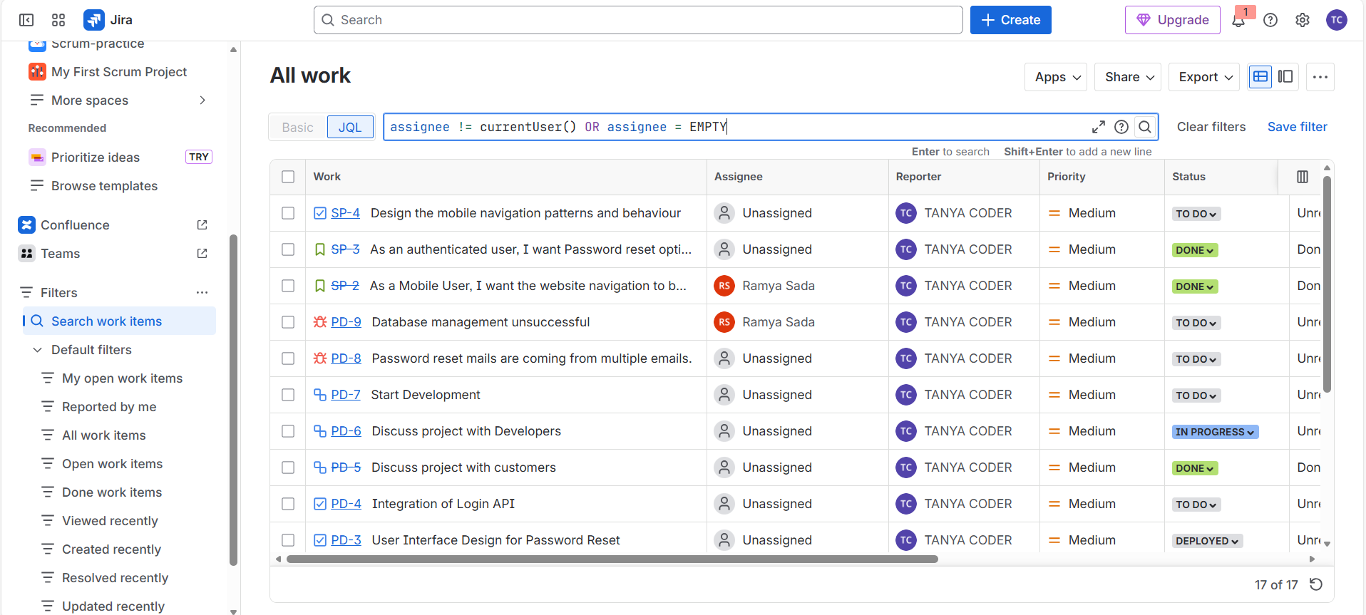

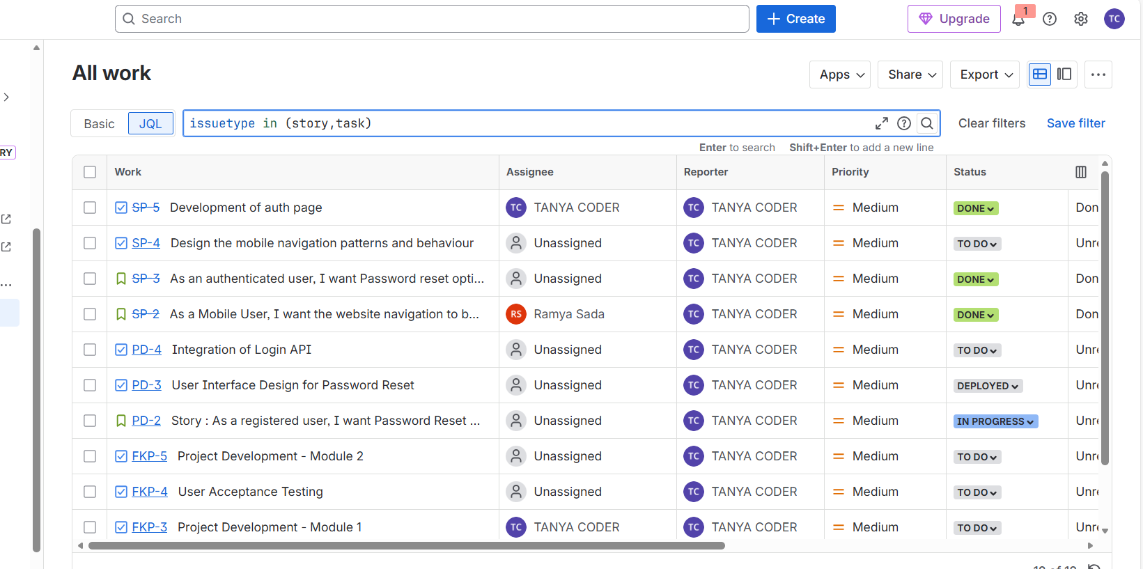

Time Based JQL Queries : Finding Work items by Date and Time:

Shows all work items from early to latest:
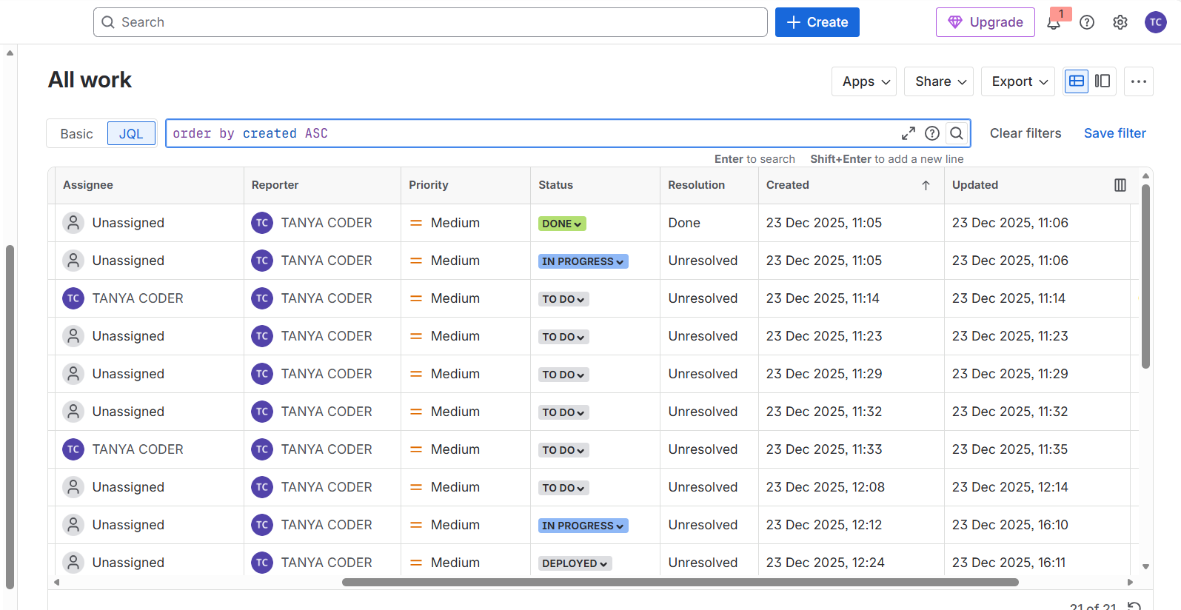

Shows the work items created in last 30 days:
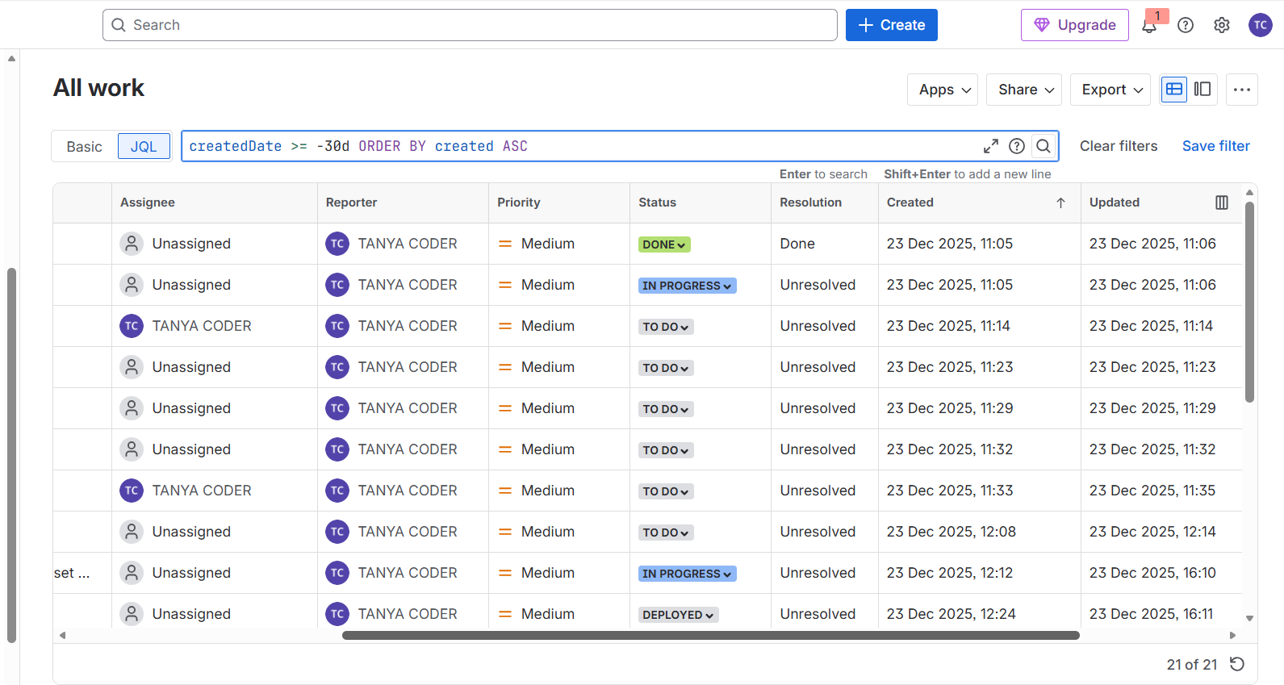

Shows the work item(s) that are linked to specified work item:
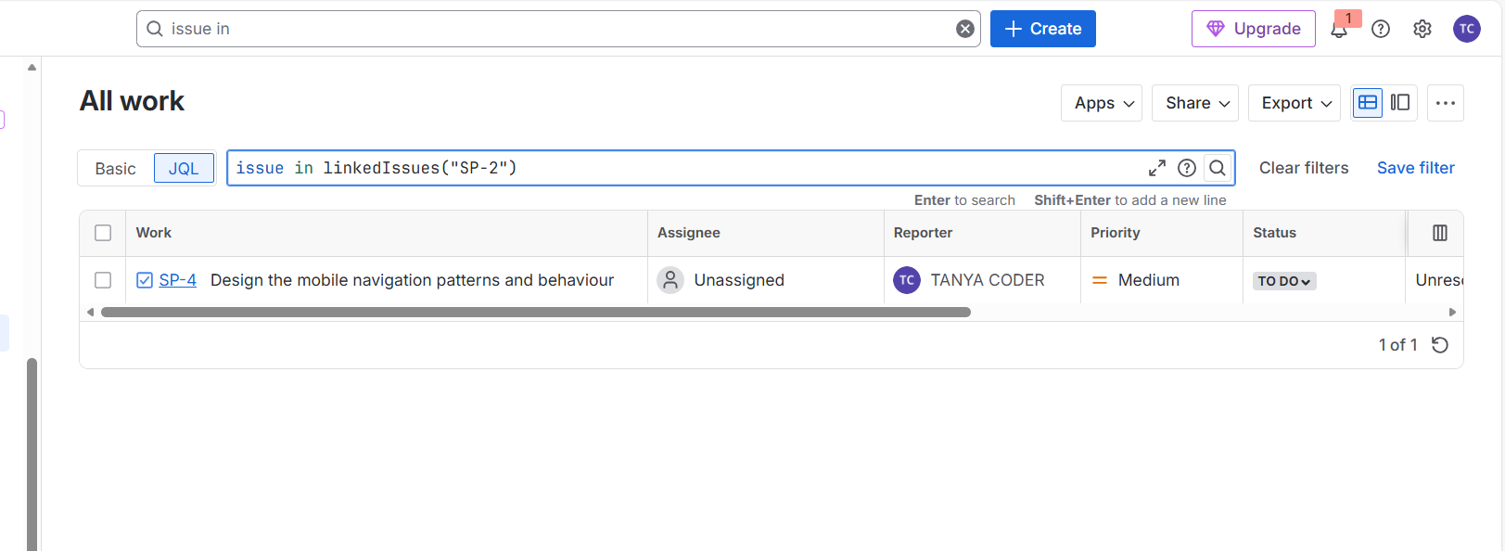

Shows the work item(s) that contain Login in description:
